Use-Case Specification: Payment

Version 1.0

Revision History

|  |  |  |  |
| --- | --- | --- | --- |
| **Date** | **Version** | **Description** | **Author** |
| 12/12/2019 | 1.0 | details | Tran Van Dat |
|  |  |  |  |
|  |  |  |  |
|  |  |  |  |

Table of Contents

1. Use-Case Name 3

1.1 Brief Description 3

2. Flow of Events 3

2.1 Basic Flow 3

2.2 Alternative Flows 3

3. Special Requirements 3

3.1 < First Special Requirement > 3

4. Preconditions 3

5. Postconditions 3

6. Extension Points 3

Use-Case Specification: Payment

# Payment

## Brief Description

This use-case defines the steps of payment for a bill. Customer can easily see the list thing that he has just pick through payment.

# Flow of Events

## Basic Flow

The customer clicks on payment button. Then the system displays payment form for customer fills in. But the customer has to add a cart to pay. Click to the list of order and check it again before paying. Finally, the system will bring customer back to the home page.

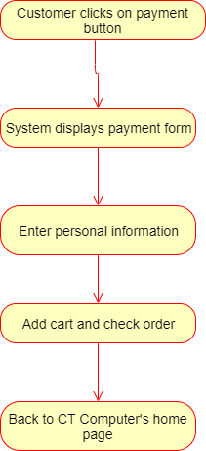

# Special Requirements

Customer must choose at least one items.

# Preconditions

Customer must order the computer before payment.

# Postconditions

No postcondition.

# Extension Points

No extension point.